# Homework: Programming Languages

Submit this document as your homework.

## JavaScript:

1. Open the Browser Console.
2. Create a **JS function** to **calculate** and **return** the **area of a rectangle**.
3. **Create the necessary constants and assign random values:**
4. **Execute the JS function** in the Browser Console:
5. **Print the calculated area on the Browser Console** in the following format: "The area of the rectangle is: areaValue sq.cm." :
6. **Example:**

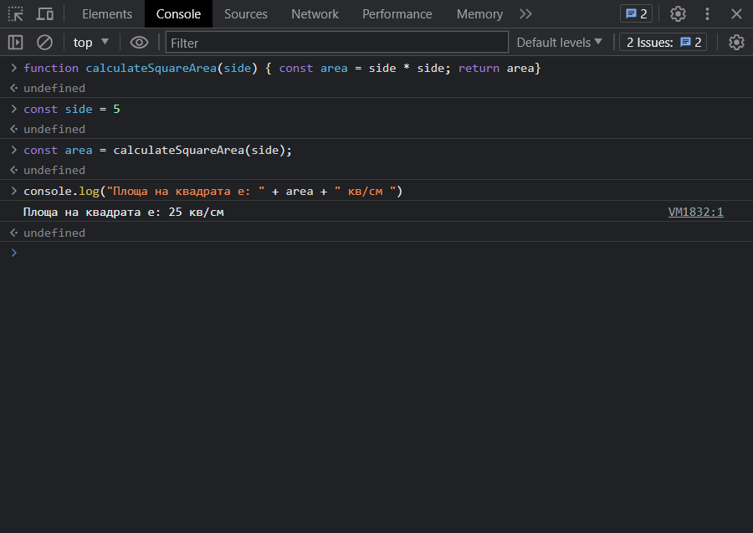

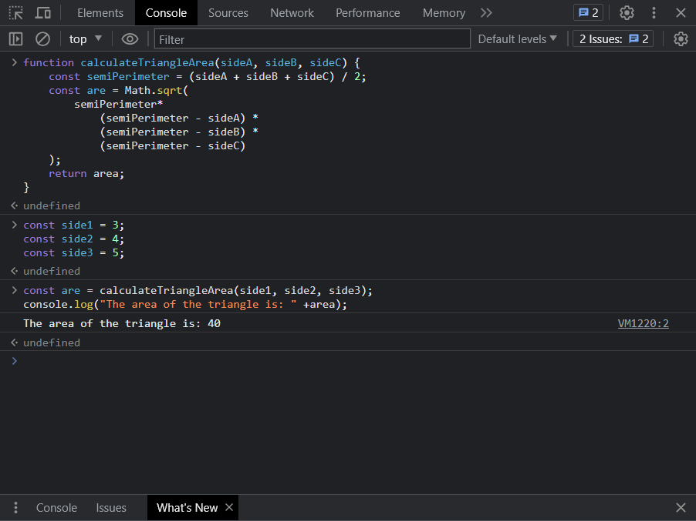

## HTML & CSS

1. **Using the tutorial from the Exercise Document, Crate a simple Web Page that looks like the Example Below.**
2. **Example:**

